1-Grammar

📘 What is Grammar?
# Source: Chatgpt (GPT-4-turbo) at [7/24/2025]
Grammar is the system of rules and structures that govern how words are formed, combined, and used in a language to create meaningful sentences.

🧠 Definition:
# Source: Chatgpt (GPT-4-turbo) at [7/24/2025]
Grammar is the set of rules that define how words and phrases are structured in a language, including word formation, sentence structure, and agreement.

🔍 Main Components of Grammar:
# Source: Chatgpt (GPT-4-turbo) at [7/24/2025]
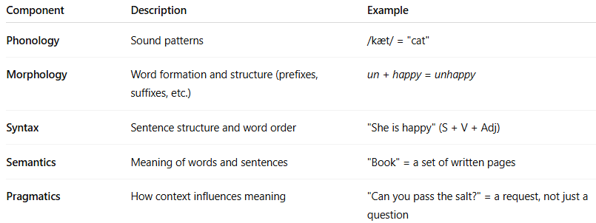
Component | Description | Example
Phonology | Sound patterns | /kæt/ = "cat"
Morphology | Word formation and structure (prefixes, suffixes, etc.) | un + happy = unhappy
Syntax | Sentence structure and word order | "She is happy" (S + V + Adj)
Semantics | Meaning of words and sentences | "Book" = a set of written pages
Pragmatics | How context influences meaning | "Can you pass the salt?" = a request, not just a question

🧾 Types of Grammar:
# Source: Chatgpt (GPT-4-turbo) at [7/24/2025]
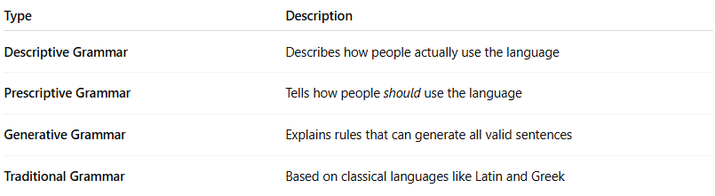
Type | Description
Descriptive Grammar | Describes how people actually use the language
Prescriptive Grammar | Tells how people should use the language
Generative Grammar | Explains rules that can generate all valid sentences
Traditional Grammar | Based on classical languages like Latin and Greek

✅ Examples of Grammar Rules:
# Source: Chatgpt (GPT-4-turbo) at [7/24/2025]
- Subject–verb agreement
→ "She runs" vs. "They run"
- Word order (syntax)
→ "The cat sat on the mat" (S-V-Prep phrase)
- Tense and aspect
→ "I am eating" vs. "I ate" vs. "I have eaten"

✅ Summary:
# Source: Chatgpt (GPT-4-turbo) at [7/24/2025]
Grammar is the rule system that governs how language works — including how words are formed and combined to create correct and meaningful sentences.

2-Grammatical Function

📘 What Is Grammatical Function?
# Source: Chatgpt (GPT-4-turbo) at [7/30/2025]
Grammatical function refers to the role a word, phrase, or clause plays within a sentence, based on syntax (sentence structure)—not just its part of speech.

🔹 Definition:
# Source: Chatgpt (GPT-4-turbo) at [7/30/2025]
A grammatical function is the syntactic role a linguistic unit (like a noun or clause) performs in a sentence—such as subject, object, or complement.
It answers the question:
🧠 “What is this word or phrase doing in the sentence?”

🧱 Common Grammatical Functions:
# Source: Chatgpt (GPT-4-turbo) at [7/30/2025]
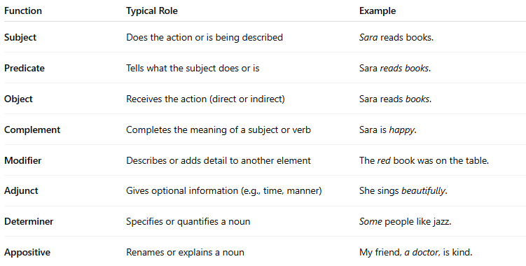
Function | Typical Role | Example
Subject | Does the action or is being described | Sara reads books.
Predicate | Tells what the subject does or is | Sara reads books.
Object | Receives the action (direct or indirect) | Sara reads books.
Complement | Completes the meaning of a subject or verb | Sara is happy.
Modifier | Describes or adds detail to another element | The red book was on the table.
Adjunct | Gives optional information (e.g., time, manner) | She sings beautifully.
Determiner | Specifies or quantifies a noun | Some people like jazz.
Appositive | Renames or explains a noun | My friend, a doctor, is kind.

🔸 Note:
# Source: Chatgpt (GPT-4-turbo) at [7/30/2025]
The part of speech (e.g., noun, verb) describes what kind of word it is.
The grammatical function describes what role it plays in a sentence.
📝 Example:
- “Apples” is a noun (part of speech)
- In “I like apples,” it functions as a direct object (grammatical function)

🧠 In Summary:
# Source: Chatgpt (GPT-4-turbo) at [7/30/2025]
Grammatical function = What the word/phrase does in the structure of the sentence.

